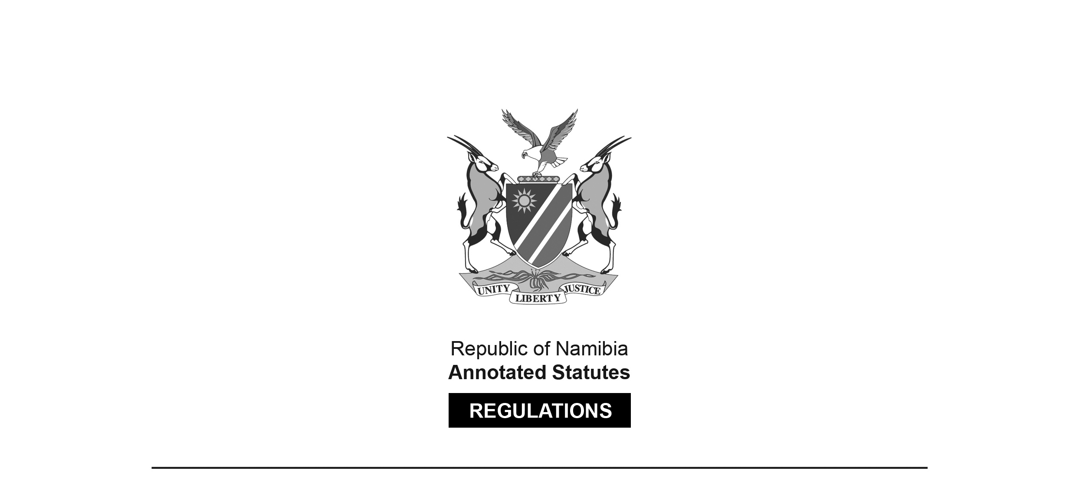

REGULATIONS MADE IN TERMS OF

Standards Act 18 of 2005

section 34(1)(d)

Alcohol-based Hand Sanitisers Regulations

Government Notice 114 of 2020

([GG 7201](http://www.lac.org.na/laws/2020/7201.pdf))

came into force on date of publication: 30 April 2020

as amended by

Government Notice 250 of 2021 **(**[GG 7687](http://www.lac.org.na/laws/2021/7687.pdf)**)**

came into force on date of publication: 18 November 2021

GN 11/2020 states that, under section 20(6) of the Standards Act, compliance with NAMS/SANS 490, published under General Notice 164/2020 ([GG 7199](http://www.lac.org.na/laws/2020/7199.pdf)), is compulsory for purposes of that section. This statement is amended by GN 250/2021 to state that compliance with the replacement NAMS/SANS 490, published under General Notice 240/2021 ([GG 7569](http://www.lac.org.na/laws/2021/7569.pdf)), is compulsory   
for purposes of that section.

ARRANGEMENT OF REGULATIONS

1. Definitions

2. Purpose of regulations

3. Specific requirements in respect of hand sanitisers

4. Registration of hand sanitisers and manufacturing facilities

5. Importing of hand sanitisers under mutual recognition agreement

6. Importing of hand sanitisers where no mutual recognition agreement exists

7. Surveillance

8. Mark of conformity

Annexure 1: Markings that must appear on packing of hand sanitisers

Annexure 2: Units of measurement, symbols and quantities

Annexure 3: Application for registration of hand sanitisers and manufacturing facilities

Annexure 4: Application procedure for importing of hand sanitisers under mutual recognition agreement

Annexure 5: Application procedure for importing hand sanitisers where no mutual recognition agreement exists

Annexure 6: Minimum height of numbers and letters

**Definitions**

**1.** In these regulations, a word or an expression to which a meaning has been given in the Act has that meaning, and unless context otherwise indicates -

“attestation of conformity” means a declaration attesting that a product is in conformity with the applicable standards and other applicable requirements;

“certificate of conformity”, in relation to hand sanitiser, means a document issued by the NSI attesting that the quality or safety of the hand sanitiser conforms to the requirements of NAMS/SANS 490 and the WHO recommendations;

“conformity assessment body” means a body that performs conformity assessment services and that is formally recognised or appointed by the NSI in a foreign country to assesses the manufacturer, distributor or the importer and the conformity of the product in accordance with the relevant standards and other applicable requirements;

[The verb “assesses” should be “assess” to be grammatically correct.]

“consumer package” means package that is customarily produced or distributed for sale to final purchasers through retail sales agencies or other means;

[The word “a” appears to have been omitted between the words “means” and “package”.]

“distributor” means a person who sources from a local manufacturer or an importer hand sanitisers registered or approved by the NSI and who sells, distributes, exchanges or otherwise deals in hand sanitisers in return for anything of value;

“expiry date”, in relation to a hand sanitiser, means the date indicating the end of the period under the stated storage conditions as specified on the label by the manufacturer until which the hand sanitiser will retain any specific qualities for which implied or expressed claims have been made;

“importer” means a person who imports hand sanitiser into Namibia;

“hand sanitiser” means a disinfectant alcohol-based hand rub, referred to in NAMS/SANS 490, which is an antiseptic agent used to cleanse the hands so as to protect and prevent the passage of bacteria, virus and other pathogens that can cause infections;

“label” means any tag, brand, mark pictorial or other descriptive matter, written, printed, stencilled, marked, embossed or impressed on, or permanently attached to, a container of a product, including labelling for the purpose of promoting its sale or disposal;

“licence” means a licence issued to an importer to import a hand sanitiser from a manufacturer in a country of origin of the hand sanitiser into Namibia where no mutual recognition agreement exists;

“manufacturer” means an entity, including a factory that prepares, compounds or formulate hand sanitisers for consumer use as a hand disinfectant;

[The verb “formulate” should be “formulates”.]

“mutual recognition agreement” means an agreement under which two or more countries or conformity assessment bodies agree to recognise one another’s conformity assessments procedures and results;

“NAMS/SANS 490” means the Namibian Standard titled ‘Disinfectant alcohol-based hand rub” issued by the NSI, as in force from time to time;

[The quoted phrase appears in the *Government Gazette* with a single opening quotation mark and a double closing quotation mark, as reproduced above.]

“package” means a prepackaged good or commodity;

“packaging” means a container, blister pack, bottle, can, cover, drum, sachet, strip pack, syringe, tube, vessel, vial, wrapper or other similar article that serves as an immediately receptacle of a hand sanitiser including any other component or material necessary to perform containment and safety functions;

[There appears to be an error in the phrase “immediately receptacle”;   
it is not clear what was intended.]

“prescribed fee” means the relevant fee payable by the applicant to NSI for service rendered or to be rendered in accordance with these regulations, as published in the *Gazette* from time to time;

[definition of “prescribed fee” substituted by GN 250/2021]

“registration” means confirmation by the NSI that a hand sanitiser and manufacturing facility comply with the requirements of NAMS/SANS 490, WHO recommendations and these regulations;

“regulator” means the NSI;

“SADCMEL Document 1” means the Southern African Development Community Cooperation in Legal Metrology document providing for labelling requirements for prepacked products and general requirements for the sale of goods, as in force from time to time;

“SADCMEL Document 4” means the Southern African Development Community Cooperation in Legal Metrology document providing for tolerance permitted for the accuracy of measurement made in terms of legal metrology legislation, as in force from time to time;

“standard” includes the NAMS/SANS 490;

“the Act” means the Standards Act, 2005 (Act No. 18 of 2005);

“WHO recommendations” means the guide to local production: World Health Organisation- recommended Handrub formulations, as in force from time to time, available at https://www.who. int/gpsc/5may/Guide_to_Local_Production.pdf; and

“%(v/v)” means percent volume per volume.

**Purpose of regulations**

**2.** The purpose of these regulations is to -

(a) declare that compliance with NAMS/SANS 490 published under General Notice No. 240 of 1 July 2021 is compulsory in terms of section 20(6) of the Act;

[paragraph (a) substituted by GN 250/2021]

(b) stipulate the quality and safety requirements of hand sanitiser for consumer use as a hand disinfectant;

(c) include the terminology, formulations, packaging, marking or labelling requirements as they apply to a product, process or production process; and

(d) compel a manufacturer, an importer or a distributor to comply with the requirements of the NAMS/SANS 490, WHO recommendations and these regulations.

**Specific requirements in respect of hand sanitisers**

**3.** (1) A person must not -

(a) manufacture or distribute a hand sanitiser in Namibia; or

(b) import a hand sanitiser into Namibia,

unless the person complies with these regulations.

(2) A manufacturer, an importer or a distributor of a hand sanitiser must comply with the requirements -

(a) relating to the type, bacterial efficacy, storage stability, freedom from visible impurities and dermal irritation set out in Clause 4 of NAMS/SANS 490;

(b) of inspection and methods of test set out in Clause 5 of NAMS/SANS 490; and

(c) of packing and marking set out in Clause 6 of NAMS/SANS 490.

(3) A manufacturer must manufacture a hand sanitiser according to the following formula consistent with the WHO recommendations:

(a) alcohol (ethanol/ethyl alcohol) 75% (v/v) to 85% (v/v) or isopropyl alcohol 70% (v/v) to 80% (v/v);

(b) glycerol 1.45% (v/v);

(c) hydrogen peroxide 0.125% (v/v).

(4) An importer must not import into Namibia a hand sanitiser which has not been manufactured in accordance with the formula set out in subregulation (3).

(5) A manufacturer, an importer or a distributor of a hand sanitiser must ensure that the hand sanitiser complies with one of the following types specified in Clause 4.1 of NAMS/SANS 490:

(a) type 1: liquid type;

(b) type 2: gel type.

(6) A manufacturer, an importer or a distributor of a hand sanitiser must ensure that the hand sanitiser does not contain any other active or inactive ingredients to -

(a) improve the smell or taste of the hand sanitiser;

(b) prevent the risk of accidental ingestion in children; or

(c) impact the quality and potency of the hand sanitiser.

(7) A manufacturer, an importer or a distributor of a hand sanitiser must ensure that the ethanol (ethyl alcohol) or isopropyl alcohol active ingredient in the hand sanitiser is correct and the correct amount of the active ingredient is used in the manufacturing of the hand sanitiser.

(8) A manufacturer, an importer or a distributor of a hand sanitiser must ensure that the hand sanitiser has a material safety data sheet providing detailed and comprehensive information on -

(a) the health effects of exposure to the hand sanitiser;

(b) hazard evaluation related to the handling, storage or use of the hand sanitiser;

(c) measures to protect workers or consumers at risk of exposure to the hand sanitiser; and

(d) the emergency procedure relating to the use of the hand sanitiser.

(9) A manufacturer, an importer or a distributor of a hand sanitiser must ensure that the packaging label of the hand sanitiser is in accordance with the Trade Metrology Act, 1973 (Act No. 77 of 1973) and that the packaging of the hand sanitiser -

(a) is marked in accordance with the requirements of the SADCMEL Document 1 and Document 4;

(b) complies with marking that must appear on the packaging contemplated in Annexure 1;

(c) complies with the unit of measurements, symbols and quantities contemplated in Annexure 2; and

(d) complies with the packing and marking requirements as contemplated in clause 6 of NAMS/SANS 490.

(10) If a person manufactures, imports or distributes a hand sanitiser that does not comply with this regulation, the person commits an offence and on conviction is liable to a fine not exceeding N$5 000 or to imprisonment for a period not exceeding six months or to both such fine and such imprisonment.

**Registration of hand sanitisers and manufacturing facilities**

**4.** (1) A manufacturer of a hand sanitiser in Namibia must register with the regulator the hand sanitiser and the manufacturing facility where the hand sanitiser is manufactured.

(2) An application to register the hand sanitiser and the manufacturing facility contemplated in subregulation (1) must -

(a) be made to the regulator and on a form obtainable from the regulator;

(b) be made in accordance with the procedure set out in Annexure 3;

(c) contain a list of raw materials used in the formulation of the hand sanitiser, accompanied by a supporting certificate of analysis for each batch;

(d) contain details of the manufacturing facility where the hand sanitiser is manufactured and for which registration is sought;

(e) contain a material safety data sheet that complies with regulation 3(8);

(f) contain a hand sanitiser label that complies with regulation 3(9);

(g) specify the types and sizes (nominal volume or mass) of packaging materials in which the hand sanitiser is sold; and

(h) be accompanied by the prescribed fee for the registration of the hand sanitiser and manufacturing facility.

(3) On receipt of an application for the registration of the hand sanitiser and manufacturing facility, the regulator must assess the application and conduct an inspection of the manufacturing facility and collect samples of the hand sanitiser from the manufacturing facility.

(4) After considering the application for the registration of a hand sanitiser and manufacturing facility, the regulator must -

(a) grant the application, if the hand sanitiser and the manufacturing facility meets the requirements of these regulations and -

(i) assign a registration number to the hand sanitiser and the manufacturing facility; and

(ii) issue a certificate of conformity; or

(b) refuse the application and request the manufacturer to take any corrective steps, including the submission of new evidence of conformity before a new application for registration may be submitted by the applicant.

[There should be a comma after the phrase “including the submission of new   
evidence of conformity” to offset that phrase properly.]

(5) The regulator may impose conditions on the registration of a hand sanitiser and a manufacturing facility and which must be specified on a certificate of conformity.

(6) A certificate of conformity is valid for a period of three years.

(7) A registration number assigned under subregulation (4) must be legibly and indelibly marked on the packaging of a hand sanitiser in the following format:

“NSI Registration:” followed by the allocated registration number.

(8) If the manufacturer takes corrective action referred to in subregulation (4)(b), and the regulator subsequently grants the application, the regulator must issue a certificate of conformity.

(9) A certificate of conformity is proof that a hand sanitiser and manufacturing facility is registered with the regulator.

(10) After having afforded a manufacturer an opportunity to make representations, the regulator may withdraw a certificate of conformity if the manufacturer fails to comply with any condition imposed under subregulation (5).

(11) A manufacturer must inform the regulator of any material change in the formulation of the hand sanitiser, and in the event of such change the regulator may request that new evidence of conformity or a new application for registration be submitted by the manufacturer.

(12) If a manufacturer manufactured a hand sanitiser before the commencement of these regulations, the manufacturer must, within 21 working days after the coming into operation of these regulations, apply for the registration of the hand sanitiser and manufacturing facility in accordance with this regulation.

(13) If a person manufactures or distributes a hand sanitiser that is not registered in terms of this regulation, the person commits an offence and on conviction is liable to a fine not exceeding N$5 000 or to imprisonment for a period not exceeding six months or to both such fine and such imprisonment.

**Importing of hand sanitisers under mutual recognition agreement**

**5.** (1) If a mutual recognition agreement exists between the regulator and a conformity assessment body in the country of origin of a hand sanitiser, the regulator may accept evaluation results of the hand sanitiser from the conformity assessment body if -

(a) the standard used is technically equivalent to NAMS/SANS 490;

(b) the formulation used is consistent with the specifications of WHO recommendations referred to in regulation 3(3); and

(c) the criteria used to perform a conformity assessment is equivalent to the certification scheme of the regulator.

(2) If a mutual recognition agreement exists, the application procedure for importing a hand sanitiser into Namibia from a country to which the mutual recognition agreement applies, is illustrated in Annexure 4.

(3) The importer of a hand sanitiser must obtain the certificate of registration and test results as issued by the conformity assessment body in the country of origin which certify compliance of the hand sanitiser and must furnish that certificate and test results to the regulator.

(4) For each consignment of hand sanitisers, an importer must apply to the regulator for approval to import such hand sanitisers into Namibia and the application must -

(a) be made on a form obtainable from the regulator; and

(b) be accompanied by the prescribed fee for issuance of attestation of conformity.

(5) On receipt of an application under subregulation (4), the regulator may issue the attestation of conformity per consignment to import hand sanitisers into Namibia and the attestation conformity is valid for 21 days.

(6) Proof of conformity with a standard contemplated in subregulation (1) is proof that a hand sanitiser conforms to the corresponding standard and other requirements in Namibia.

(7) The regulator may conduct a physical verification of the quantities of the hand sanitisers to be imported and collect samples of the hand sanitiser for testing and analysis to confirm compliance with NAMS/SANS 490 and WHO recommendations.

(8) If a person imports or distributes a hand sanitiser that is not in compliance with this regulation, the person commits an offence and on conviction is liable to a fine not exceeding N$5 000 or to imprisonment for a period not exceeding six months or to both such fine and such imprisonment.

**Importing of hand sanitisers where no mutual recognition agreement exists**

**6.** (1) If a mutual recognition agreement does not exist between the regulator and a conformity assessment body in the country of origin of the hand sanitiser, the importer must apply to the regulator for an approval of the hand sanitiser and manufacturing facility before the hand sanitiser may be imported into Namibia.

(2) An application for the approval referred to in subregulation (1) must -

(a) be made to the regulator and on a form obtainable from the regulator;

(b) be made in accordance with the procedure set out in Annexure 5;

(c) contain a list of raw materials used in the formulation of the hand sanitiser, accompanied by a supporting certificate of analysis for each batch;

(d) contain details of the manufacturing facility where the hand sanitiser is manufactured and for which approval is sought, and the standards to which it conforms;

(e) contain a material safety data sheet that complies with regulation 3(8);

(f) contain a hand sanitiser label that complies with regulation 3(9);

(g) specify the type and size (nominal volume or mass) of packaging material in which the hand sanitiser is sold; and

(h) be accompanied by the prescribed fee for the approval of the hand sanitiser and manufacturing facility.

(3) On receipt of an application for approval of a hand sanitiser and manufacturing facility, the regulator must assess the application and conduct an inspection of the hand sanitiser and manufacturing facility in the country of origin and collect samples of the hand sanitisers from the manufacturing facility.

(4) After considering an application for the registration of a hand sanitiser and manufacturing facility, the regulator -

(a) must grant the application, if the hand sanitiser and the manufacturing facility meets the requirements of these regulations, and issue a licence to an importer; or

[The verb “meets” should be “meet” to match the subject   
“the hand sanitiser and the manufacturing facility”.]

(b) may refuse the application if the applicant does not meet the requirements of these regulations and give written reasons for the refusal of the application to the applicant.

(5) The regulator must only issue a licence if the regulator is satisfied that -

(a) the hand sanitiser meets all the requirements contemplated in regulation 3; and

(b) the manufacturing facility, in manufacturing hand sanitisers, uses the standards and the criteria to perform a conformity assessment that complies with regulation 5(1).

(6) The regulator must assign a unique number to each licence issued in respect of each hand sanitiser and manufacturing facility approved in terms of this regulation.

(7) The licence issued is proof that the hand sanitiser and manufacturing facility have been approved by the regulator for purposes of this regulation, and the licence is valid for one year.

(8) The regulator may impose conditions on the licence issued to an importer and the regulator, after having afforded an importer an opportunity to make representations, may withdraw the licence if the importer fails to comply with any condition imposed on the licence.

**Surveillance**

**7.** (1) The regulator must collect a minimum of six samples annually of each kind of hand sanitiser -

(a) imported into Namibia from a depot of an importer in Namibia; or

(b) manufactured in a manufacturing facility in Namibia,

and test the samples to confirm continuous compliance with these regulations.

(2) The regulator must conduct -

(a) an on-site surveillance inspection for a Namibian manufacturer in the first and second year of registration; and

(b) a re-registration in the third year.

**Mark of conformity**

**8.** (1) A manufacturer must affix on the packaging of a hand sanitiser manufactured in Namibia and registered in terms of these regulations, the NSI standard mark of conformity for the hand sanitiser.

(2) If a manufacturer fails to affix the mark referred to in subregulation (1), the manufacturer commits an offence and is liable upon conviction to a fine not exceeding N$5 000 or to imprisonment for a period not exceeding six months or both such fine and such imprisonment.

**Annexure 1**

**Markings that must appear on packaging of hand sanitisers**

(1) The manufacturer must be guided by the NAMS/SANS 490 and WHO recommendations, and the information appearing on a package of a hand sanitiser must not be deceptive to the users.

(2) The nominal value or mass of the contents of the hand sanitiser must be marked in accordance with the units of measurement, symbols and quantities specified in Annexure 2.

(3) The following information must be attached to, or accompany, the hand sanitiser packaging:

(a) name and place of business of the manufacturer, importer or distributor, and in the case of a hand sanitiser packed for any other person, the full name and address of that person;

(b) the identity of the hand sanitiser, including hand sanitiser’s name, trademark, generic name, common or usual name;

(c) batch identification that provides traceability to the date of packing or dispatch in the case of bulk production and the production date of the batch;

(d) the expiry date of the hand sanitiser, which may not be more than two years from the date of manufacture;

(e) the name and percentage of the active ingredient and percentage in letters of a minimum height as specified in Annexure 6;

(f) the NSI registration number referred to in regulation 4(4);

(g) the recommended method of application, use concentration and volume to be applied and application procedure;

(h) the warning that the hand sanitiser is not intended for internal use (ingestion) and that the hand sanitiser must be stored away from children, flame or heat;

(i) the first aid measures to be taken for different exposure routes in cases of inhalation, eye contact and ingestion, if necessary;

(j) a statement of quantity as specified in SADCMEL Document 1 and Document 4.

(4) The information required to be attached or accompany the hand sanitiser packaging in terms of subparagraph (3) must be printed legibly and indelibly on each container of the hand sanitiser in the English language.

(5) Packages must be manufactured, constructed or displayed in such a manner that a purchaser may not reasonably be misled with respect to the quantity or identity of the hand sanitiser.

**Annexure 2**

**Units of measurements, symbols and quantities**

(1) Consumer packages of the hand sanitiser must be expressed and sold in litres or in fractions of the units, expressed by the symbol L/l or mL/ml, (in order to avoid the risk of confusion of the letter l and the number 1, the script letters ℓ for litre are acceptable) -

(a) neither a period (full stop) nor the letter “s” must be used after any of the symbols;

(b) single space must be used to separate the number from the unit of measurement;

(c) appropriate phrases such as “net”, “net mass”, “net contents” or “net quantity” may be used in connection with the net quantity declaration, and such phrases may appear either before or after the net quantity declaration;

(d) the words “approximately” and “when packed” may not be used; and

(e) the decimal indicator must be either the comma or a dot on the line.

(2) Pre-packaged hand sanitiser must be sold in the following quantities:

(a) minimum quantity of 10 mL;

(b) then in integral multiples of 5 mL from 10 mL up to and including 100 mL;

(c) then 125 mL, 150 mL, 175 mL, 200 mL, 250 mL, 300 mL, 350 mL, 375 mL, 400 mL, 450 mL, 500 mL, 750 mL, 800 mL 1 L, 1.25 L, 1.5 L, 2 L, 2.5 L, 3 L, 3.5 L, 4 L, 4.5 L, 5 L, 20 L, 25 L, and integral multiples of 1 L above 25 L.

**Annexure 3**

**Application for registration of hand sanitisers and manufacturing facilities**

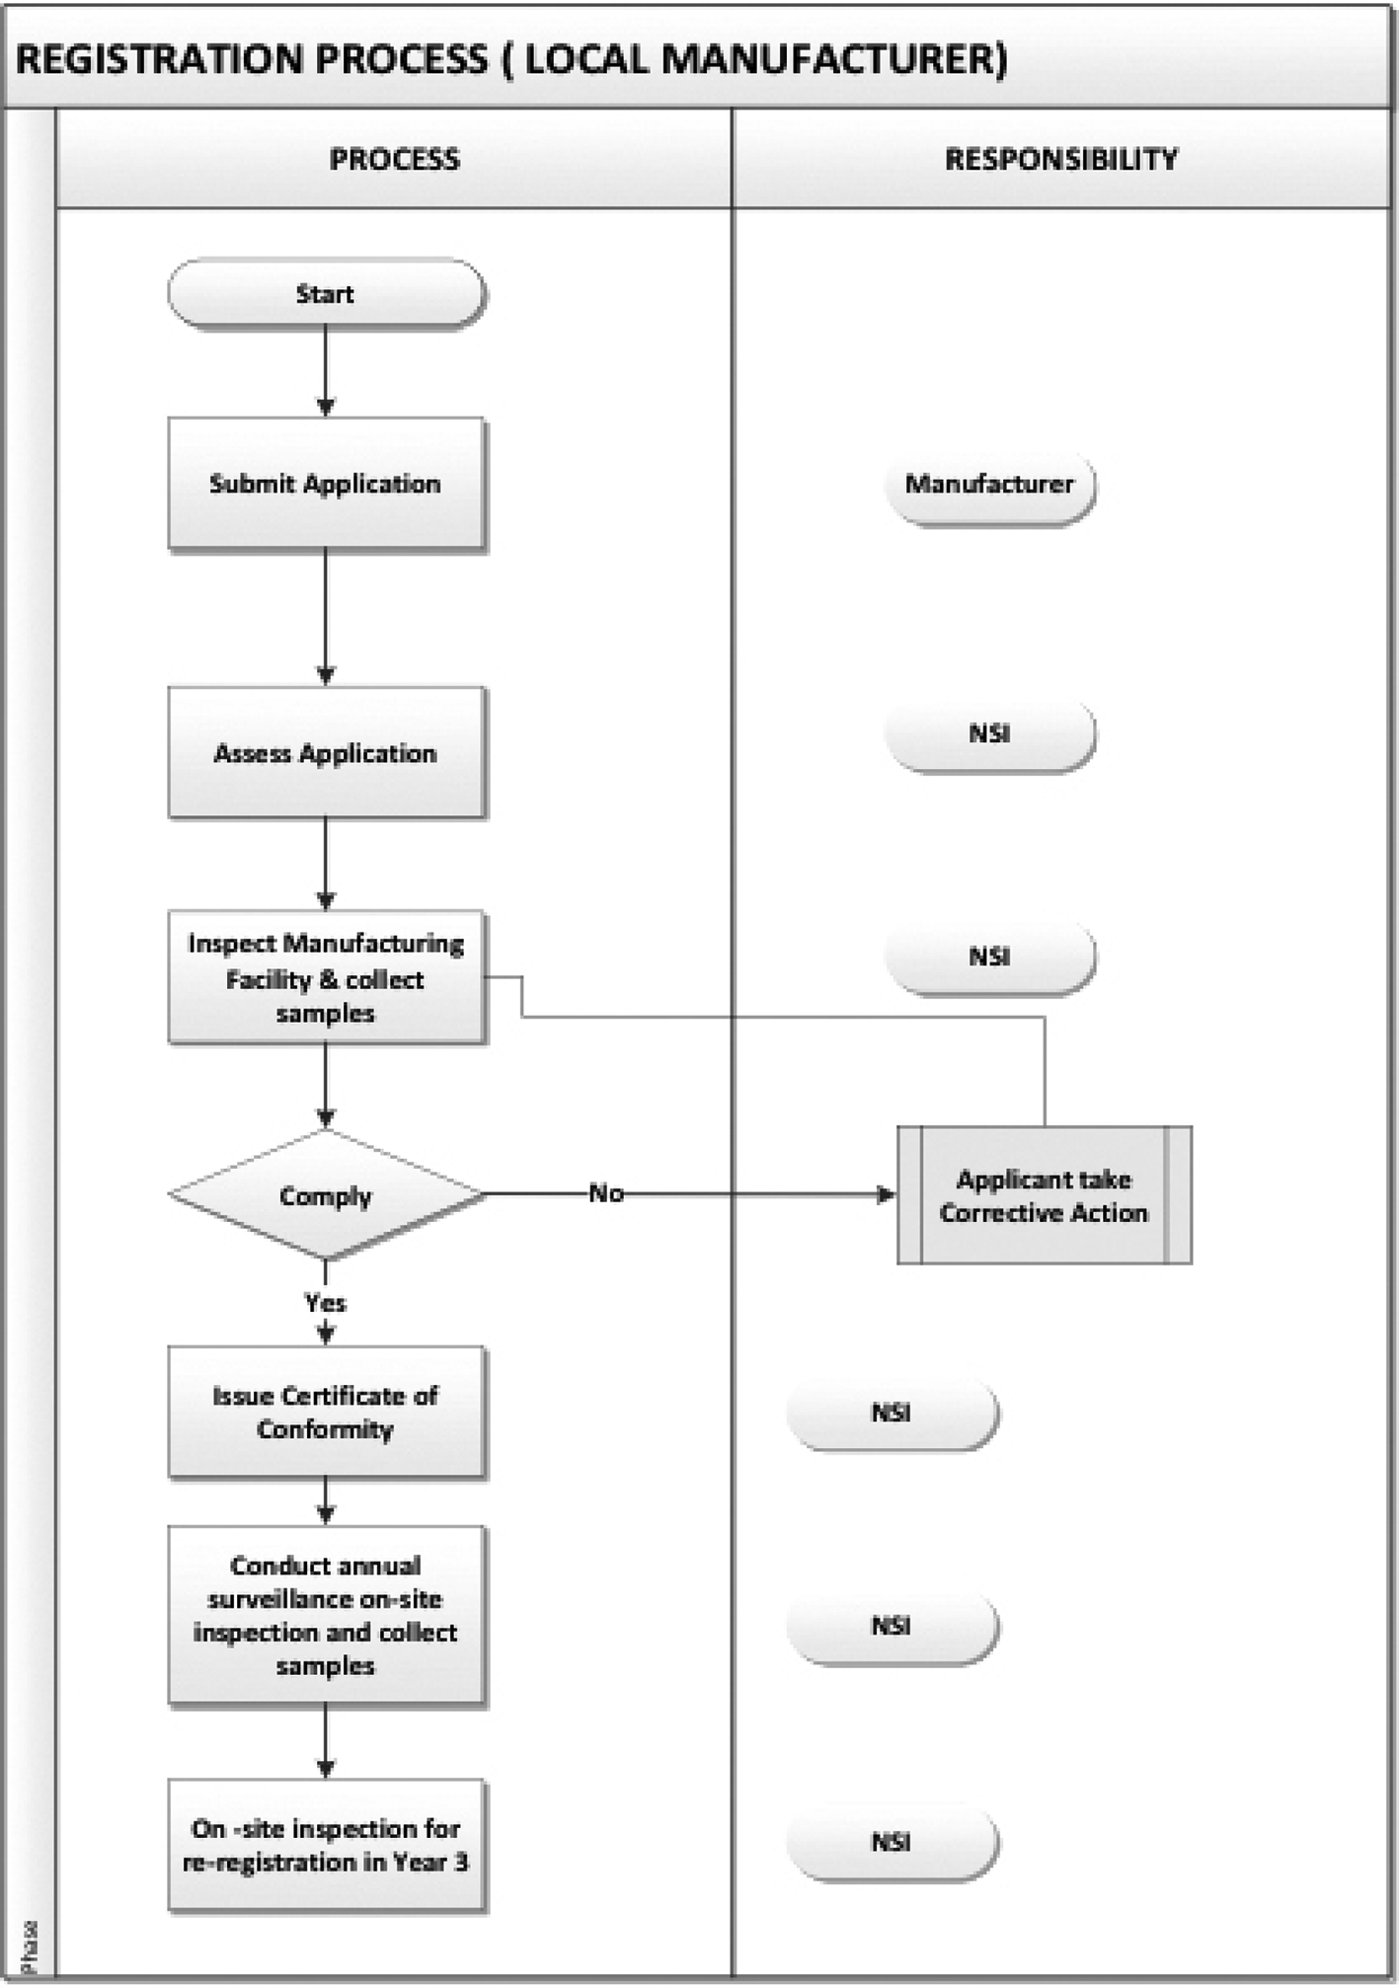

**Annexure 4**

**Application procedure for importing of hand sanitisers under mutual recognition agreement**

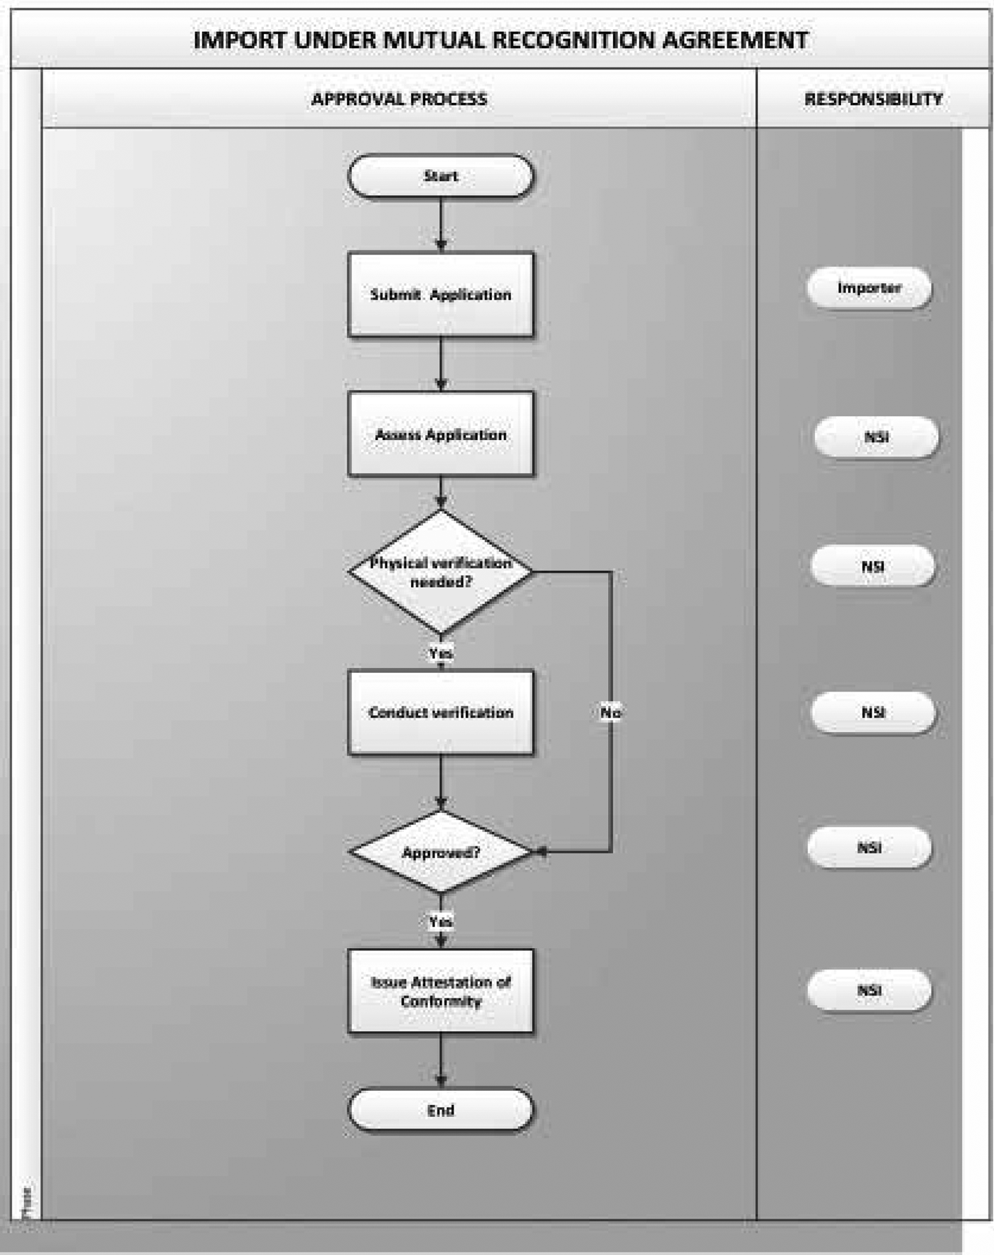

**Annexure 5**

**Application procedure for importing of hand sanitisers where no mutual recognition agreement exists**

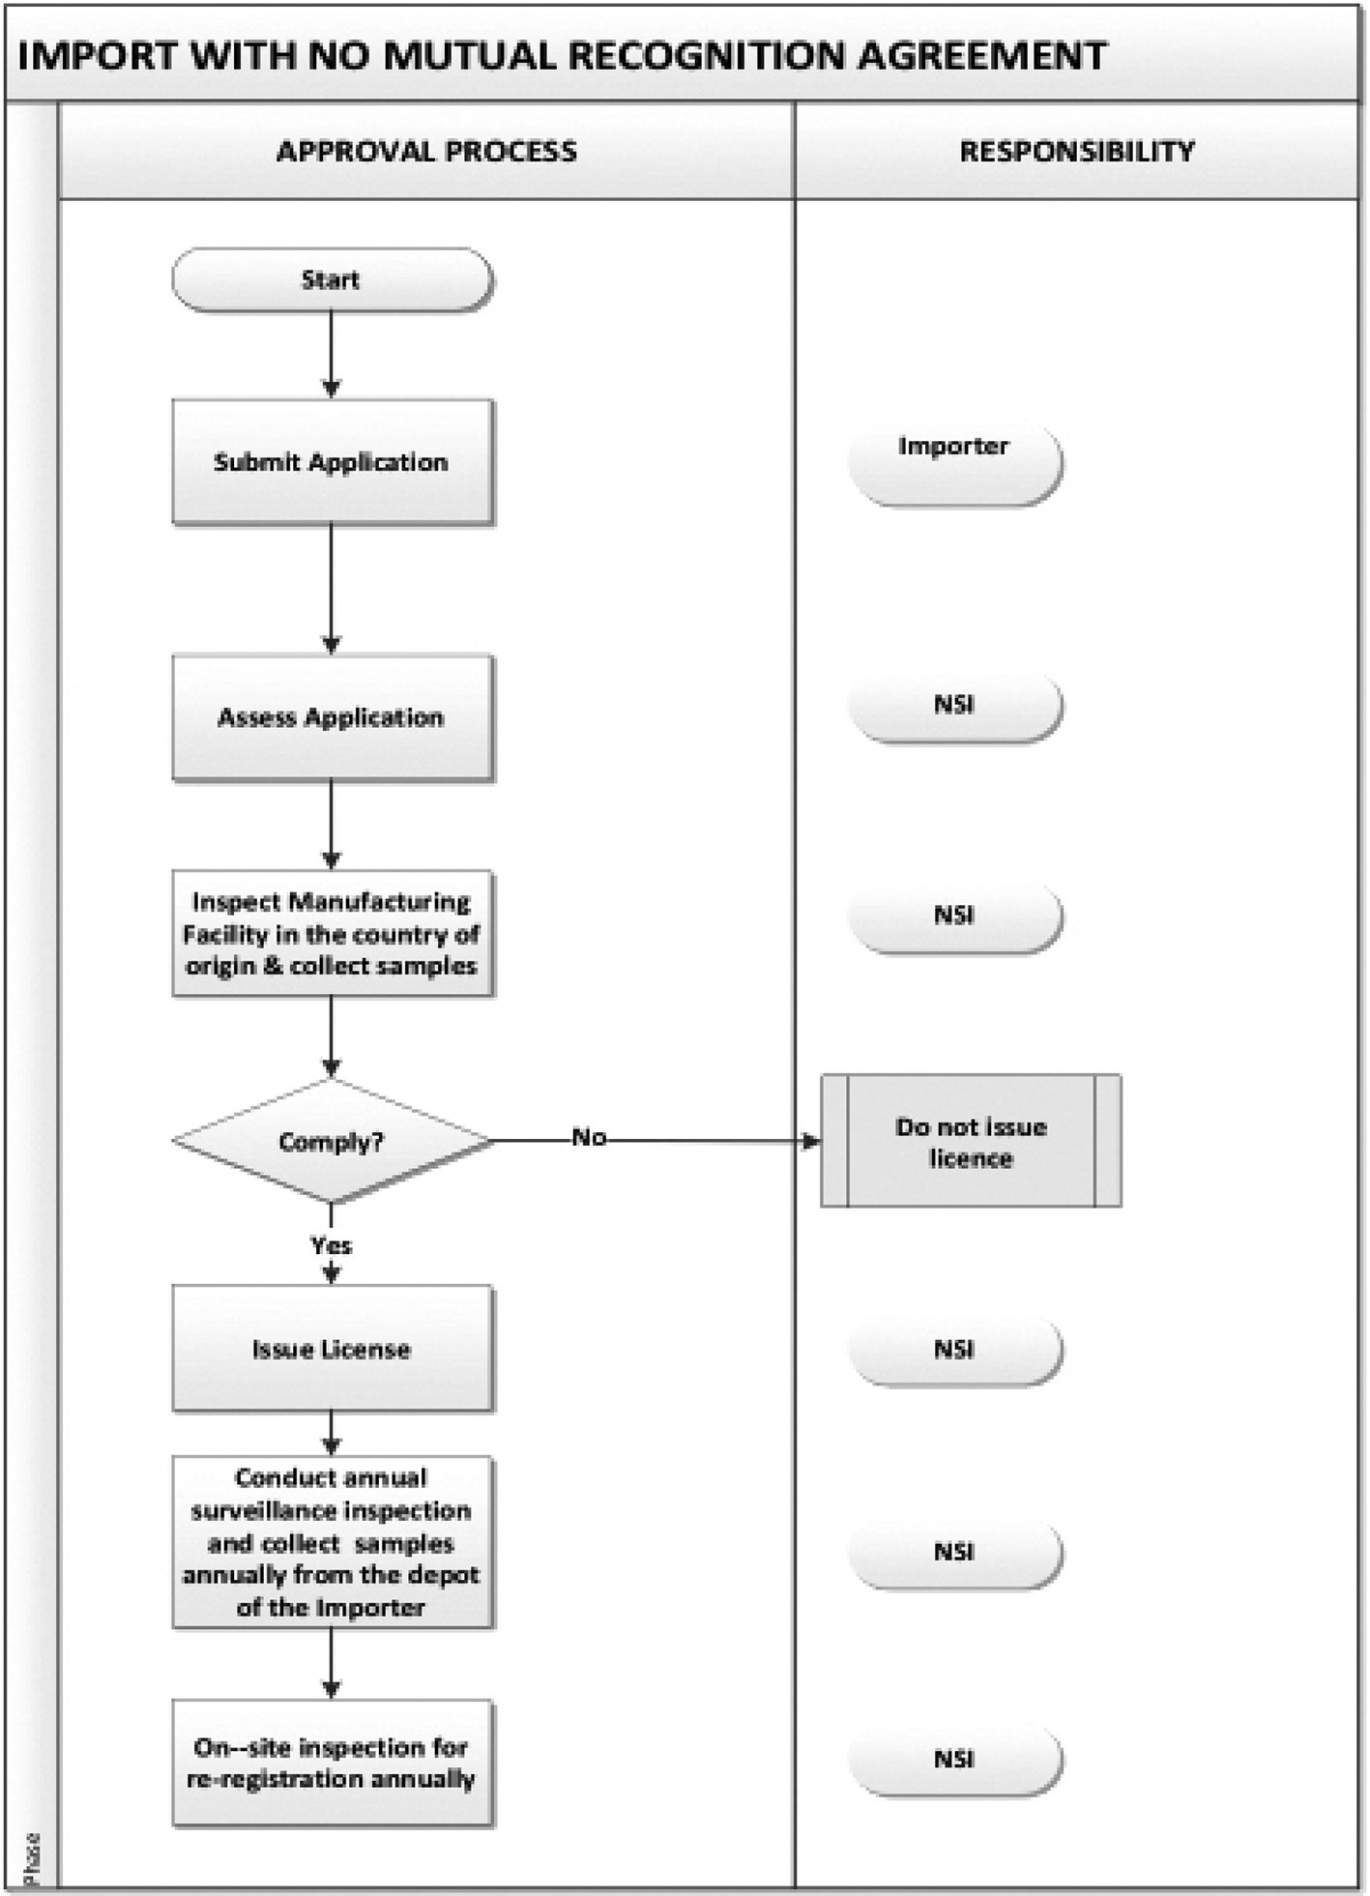

**Annexure 6**

**Minimum height of numbers and letters**

|  |  |
| --- | --- |
| Net contents ( *C* ) | Minimum height of numbers and letters in millimetres |
| *C* ≤ 50 mL | 2 |
| 50 mL < *C* ≤ 200 mL | 3 |
| 200 mL < *C* ≤ L | 4 |
| 1 L < *C* | 6 |